Дата: 22.02.2023 Клас: 7-А

Предмет: Англійська мова

Тема: Виконуємо поради лікаря.

Мета: повторити та активізувати в мовленні учнів лексичний та граматичний матеріал теми, удосконалювати навички аудіювання, тренувати техніку читання,розвивати комунікативні здібності, практикувати учнів у письмі, заохочувати учнів піклуватися про своє здоровя та відмовлятися від шкідливих звичок, виховувати в учнів бажання вести здоровий спосіб життя.

Вчитель: Глуговська Л.Г.

**Хід уроку**

***1.Greeting***

Good afternoon, dear children! I’m glad to see you. Are you ready to start our lesson? Let’s start.

***2. Vocabulary box***

Запишемо нові слова у словник:

* *Pediatrician – педіатр*
* *Oculist – окуліст*
* *Therapeutist – терапевт*
* *Physician – лікар*
* *Cardiologist – кардіолог*
* *Pharmacist – фармацевт*

***3. Warm-up***

What’s the matter? Match the problem and its solution.

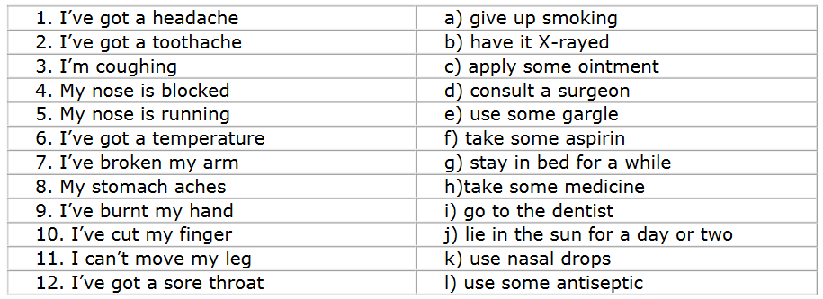

***4. Speaking***

Do ex. 5, p. 118

Використовуючи Past Perfect (минулий доконаний час) утворіть речення.

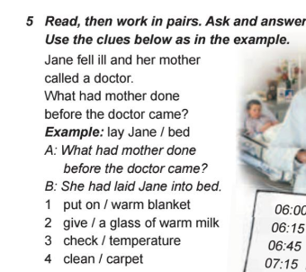

***5. Listening***

*Перегляньте відео з теми.*

«Health Problems - English Vocabulary»

[***https://www.youtube.com/watch?v=Zm1KKcgQ7DM***](https://www.youtube.com/watch?v=Zm1KKcgQ7DM)

***6. Reading***

Read to the text and do the tasks.

***A VISIT TO THE DOCTOR***  
Once an old gentleman came to consult a doctor.  
“What do you complain of?” asked the doctor.  
“You see, doctor, my nervous system is in a bad state. I have a heartache, often headache and my sleep isn’t good. Sometimes I cannot sleep all night long”.  
The doctor examined the patient very carefully and said:  
“Your treatment will be very simple, in other words it will be a rest-cure. You should go to a quiet place in the village for a month and have an active rest there: get up early, do morning exercises, have breakfast and go for a walk. You should walk much, go to the forest for fresh air, eat much fruit and vegetables and drink milk before going to bed. And you can smoke only one cigarette a day.

A month later the gentleman came to see the doctor again.  
“How are you?” asked the doctor.  
“I am quite well now”, answered the patient. “I’ve done everything that you  
recommended me, doctor. I strictly followed all your orders. I walked much, ate much fruit and vegetables and drank milk before going to sleep. But one cigarette a day almost killed me”.  
“But why?” asked the doctor.  
“It’s not a joke to begin smoking at my age. I had never smoked before”, answered the gentleman.

***7. Writing***

***Wednesday, the twenty second of February***

***Homework***

Say if the following statements true or false.

1. The man was old.

2. The man complained of only the headache.

3. The doctor advised him to have an active rest.

4. The man came back in a month.

5. After the rest the man felt bad.

6. The man enjoyed smoking.

***8. Homework***

Домашнє завдання:

1. Опрацювати конспект, вивчити слова;

2. Виконати письмово вправу з розділу ***Writing.***

**Надіслати виконане завдання у Вайбер/телеграм (0964124047) – Людмила Григорівна або на Human**.